**Practical 1**

Turn an LED on and off every second.

**// c++ code**

**int led=12;**

**void setup()**

**{**

**pinMode(led, OUTPUT);**

**}**

**void loop()**

**{**

**digitalWrite(led, HIGH);**

**delay(200);**

**digitalWrite(led, LOW);**

**delay(200);**

**}**

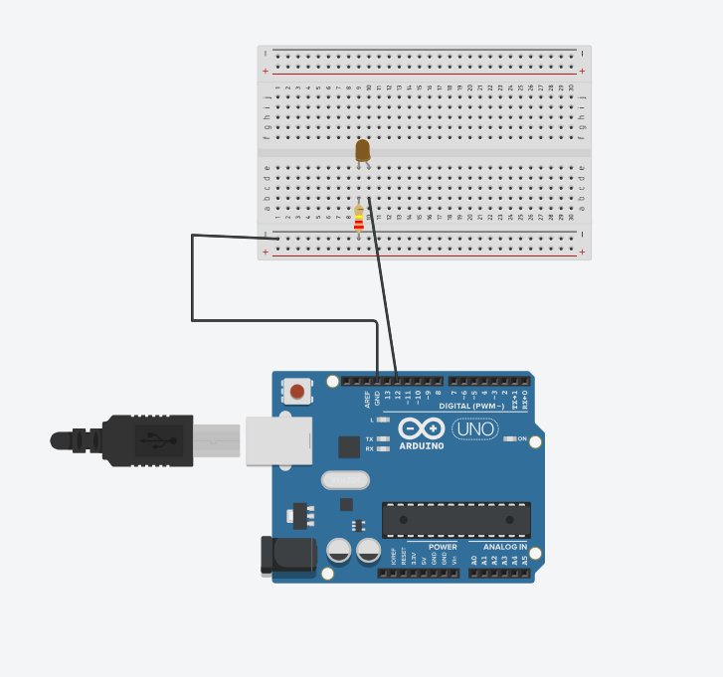

**Practical 2**

Create a program that illuminates the green LED if the counter is less than 100, illuminates the yellow LED if the counter is between 101 and 200 and illuminates the red LED if the counter is greater than 200

**Code**

int counter = 0;

void setup()

{

Serial.begin(9600);

pinMode(7,OUTPUT);

pinMode(8,OUTPUT);

pinMode(9,OUTPUT);

}

void loop() {

if(counter == 31)

{

counter=0;

}

if(counter < 31)

{

Serial.println(counter);

}

counter = counter + 1;

delay(100);

if(counter > 0 && counter < 11 )

{

digitalWrite(7,HIGH);

digitalWrite(8,LOW);

digitalWrite(9,LOW);

}

if(counter > 10 && counter < 21 )

{

digitalWrite(7,LOW);

digitalWrite(8,HIGH);

digitalWrite(9,LOW);

}

if(counter > 20 && counter < 31 )

{

digitalWrite(7,LOW);

digitalWrite(8,LOW);

digitalWrite(9,HIGH);

}

}

